# RFID Basics Backscatter Radio Links and Link Budgets

Quelle: <http://www.eetimes.com/document.asp?doc_id=1276306>

**Backscatter Radio Links**  
Passive and semipassive RFID tags do not use a radio transmitter; instead, they use modulation of the reflected power from the tag antenna. Reflection of radio waves from an object has been a subject of active study since the development of radar began in the 1930s, and the use of backscattered radio for communications since Harry Stockman's work in 1949.

A very simple way to understand backscatter modulation is shown schematically in **Figure 3.14**: current flowing on a transmitting antenna leads to a voltage induced on a receiving antenna. If the antenna is connected to a load, which presents little impediment to current flow, it seems reasonable that a current will be induced on the receiving antenna.

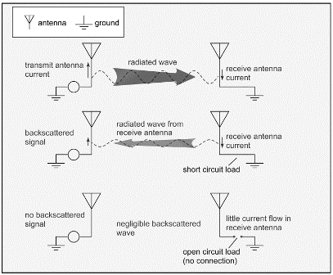

*3.14. Simplified Physics of Backscatter Signaling.*

In the figure, the smallest possible load, a short circuit, is illustrated. This induced current is no different from the current on the transmitting antenna that started things out in the first place: it leads to radiation. (A principle of electromagnetic theory almost always valid in the ordinary world, the principle of reciprocity, says that any structure that receives a wave can also transmit a wave.) The radiated wave can make its way back to the transmitting antenna, induce a voltage, and therefore, produce a signal that can be detected: a *backscattered* signal. On the other hand, if instead a load that permits little current to flow (that is, a load with a large *impedance*) is placed between the antenna and ground, it seems reasonable that little or no induced current will result. In Figure 3.14, we show the largest possible load, an open circuit (no connection at all). Since it is currents on the antenna that lead to radiation, there will be no backscattered signal in this case. Therefore, the signal on the transmitting antenna is sensitive to the load connected to the receiving antenna.

To construct a practical communications link using this scheme, we can attach a transistor as the antenna load (**Figure 3.15**). When the transistor gate contact is held at the appropriate potential to turn the transistor on, current travels readily through the channel, similar to a short circuit. When the gate is turned off, the channel becomes substantially nonconductive. Since the current induced on the antenna, and thus, the backscattered wave received at the reader, depend on the load presented to the antenna, this scheme creates a modulated backscattered wave at the reader.

Note that the modulating signal presented to the transistor is a baseband signal at a low frequency of a few hundred kHz at most, even though the reflected signal to the reader may be at 915 MHz. The use of the backscatter link means that the modulation switching circuitry in the tag only needs to operate at modest frequencies comparable to the data, not the carrier frequency, resulting in savings of cost and power. (Real RFID tag ICs are not quite this simple and may use a small change in capacitance to modulate the antenna current instead.)

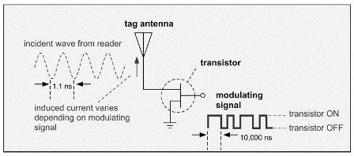

*3.15. Modulated Backscatter Using a Transistor as a Switch.*

Note that in order to implement a backscattered scheme, the reader must transmit a signal. In many radio systems, the transmitter turns off when the receiver is trying to acquire a signal; this scheme is known as *half-duple*x to distinguish it from the case where the transmitter and receiver may operate simultaneously (known as a *full-duplex* radio).   
  
In a passive RFID system, the transmitter does not turn itself off but instead, transmits CW during the time the receiver is listening for the tag signal. RFID radios use specialized components known as circulators or couplers to allow only reflected signals to get to the receiver, which might otherwise be saturated by the huge transmitted signal. However, in a single-antenna system, the transmitted signal from the reader bounces off its own antenna back into the receiver, and the transmitted wave from the antenna bounces off any nearby objects such as desks, tables, people, coffee cups, metal boxes, and all the other junk that real environments are filled with, in addition to the poor little tag antenna we're trying to see (**Figure 3.16**).

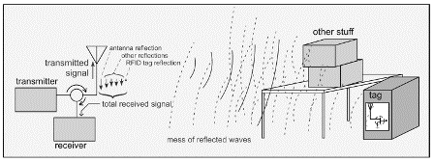

*3.16. Realistic Environments Create Many Reflected Waves in Addition to that from the Wanted Tag*

If two antennas are used (one for transmit and one for receive), there is still typically some signal power that leaks directly from one to the other, as well as the aforesaid spurious reflections from objects in the neighborhood. The total signal at the receiver is the *vector* sum of all these contributions, most of which are much larger than the wanted tag signal, with appropriate amplitudes and phases, most of which are unpredictable *a priori*. Thus, the actual effect of a given change in the load on the tag antenna on the receiver signal is completely unpredictable and uncontrollable. For example, modulating the size of the tag antenna current (amplitude modulation) may not result in the same kind of change in the reader signal.

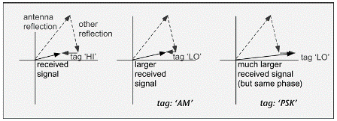

*3.17. The Received Signal is not Simply Correlated to the Tag Signal. The AM Case Assumes the Tag Reduces its Scattered Magnitude Without Changing Phase; the Phase Shift Keying (PSK) Case Assumes Phase Inversion Without Amplitude Change.*

In **Figure 3.17**, we show a case where changing the tag reflection from a large amplitude (HI) to a small amplitude (LO) causes the received signal to increase in magnitude without changing phase (the "AM" case). Changing the phase of the tag signal without changing the size of the reflected signal in order to symbolize a local oscillator (LO) state may change the amplitude of the reader signal at constant phase (Figure 3.17, PSK case). The only thing we can say with any confidence is that when we make a change in the state of the tag antenna, something about the phase or amplitude of the reader signal will change.

In order to make a backscatter link work, we need to choose a way to code the data that can be interpreted based only on these changes and not on their direction or on whether they are changes in phase or amplitude. As a consequence, all approaches to coding the tag signal are based on counting the number of changes in tag state in a given time interval, or equivalently on changing the frequency of the tag's state changes.

Therefore, all tag codes are variations of frequency-shift keying (FSK). It is important to note that the frequency being referred to here is not the radio carrier frequency of (say) 900 MHz but the tag (baseband) frequency of perhaps 100 or 200 kHz. A binary '1' might be coded by having the tag flip its state 100 times per millisecond, and a binary '0' might have 50 flips per millisecond.

Because the frequency being changed is the frequency at which a carrier is being amplitude modulated, techniques like this are sometimes known as *subcarrier modulation*. Let's look at one specific example of tag coding, usually known as *FM0* (**Figure 3.18**).

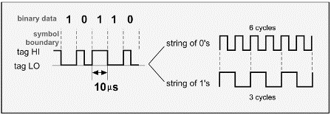

*3.18. FM0 Encoding of Tag Data.*

In FM0, the tag state changes at the beginning and end of every symbol. In addition, a binary 0 has an additional state change in the middle of the symbol. Note that, unlike OOK, the actual tag state does not reliably correspond to the binary bit: for example, in the left-hand side of the figure, two of the binary '1' symbols have the tag in the LO state and another '1' symbol has the tag in the HI state. Remember, the reader can't reliably distinguish which state is which but can only count transitions between them. The right side of the figure shows the baseband signal corresponding to a series of identical binary bits to clarify the correspondence of binary '0's with a frequency twice as high as that of binary '1's. Different tag coding schemes can be used to adjust the offset from the carrier frequency at which the signal from the tags is found. Readers have an easier time seeing a tag signal when it is well separated from their own carrier frequency, so higher subcarrier frequencies help improve the ability to read a tag signal. However, if the separation is large compared to the channel size, the tag signal might lie on the signal of another reader in a different channel. Just as with readers, increasing the data rate of a tag signal tends to spread the spectrum out in frequency. To have a flexible choice of tag data rates while minimizing noise, the reader needs to be able to adapt the band of frequencies it tries to receive, adding cost and complexity.

In real receivers, noise and interference may be present as well as the desired signal. A certain minimum signal-to-noise ratio (S/N) is necessary for each type of modulation in order that it can be reliably decoded by the receiver. The exact (S/N) threshold depends on how accurate you're trying to be and to a lesser extent on the algorithms used for demodulation/decoding. For RFID using FM0, (S/N) of around 10 or better (10 dB or more) is usually sufficient. (Requirements for demodulation of reader symbols, like PIE, in the tag are generally similar.)

**Link Budgets**  
Let's summarize the message of the last couple of sections. To transmit to a tag, a reader uses amplitude modulation to send a series of digital symbols. The symbols are coded to ensure that sufficient power is always being transmitted regardless of the data contained within in. The received signal can be demodulated using a very simple power detection scheme to produce a baseband voltage, which is then decoded by the tag logic. The whole scheme is depicted in Figure 3.19.

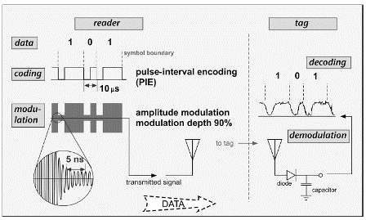

*3.19. Schematic Depiction of Reader-to-tag Data Link.*

**Figure 3.20** shows the corresponding tag-to-reader arrangements. The tag codes the data it wishes to send and then induces changes in the impedance state of the antenna. The reader CW signal bounces off the tag antenna (competing with other reflections) and is demodulated by the reader receiver and then decoded back into the transmitted data.

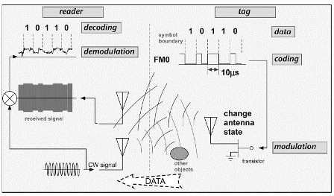

*3.20. Schematic Depiction of Tag-to-reader Data Link (A Separate Receive Antenna is Shown for Clarity).*

While we have alluded several times to the fact that the reader must power the tag, so far we have avoided coming to grips with the crucial associated question of just how much power the tag needs to get and just how far we can go from the reader and still get it. The amount of power that one needs to deliver to a receiver across a wireless link in order that the transmitted data be successfully received is known as the link budget. Since readers and tags both talk, for an RFID system there are two separate link budgets, one associated with the reader-to-tag communication (the forward link budget) and one with the tag reply to the reader (the reverse link budget).

[Part 4](http://www.rfdesignline.com/howto/lowpowerrf/202300027) reveals how to determine the link budget.

**About the Author** Dr. Dobkin has been involved in the development, manufacturing, and marketing of communications devices, components, and systems for 28 years. He holds a BS from the California Institute of Technology, and MS and PhD degrees from Stanford University, all in Applied Physics. He is the author of two books and about 30 technical publications, and holds 7 US patents as inventor or co-inventor. He has given numerous talks and classes on radio-frequency identification in the US and Asia. He specializes in physical-layer issues: radios and signal generation, antennas, and signal propagation. Dr. Dobkin lives in Sunnyvale, CA, with his wife, Nina, children Nicholas and Amelia, and entirely too many toys and video game consoles.

*Copyright: Printed with permission from Newnes, a division of Elsevier. Copyright 2008. The RF in RFID: Passive UHF RFID in Practice by Daniel M. Dobkin. For more information about this title and other similar books, please visit* [*www.newnespress.com*](http://www.newnespress.com)